***SET 1***

***Multimeter different modes and whole functionality***

# - Digital Multimeter (V 830A)

# Cost – Rs. 700 – 800

# Dealer – Available on Amazon.com

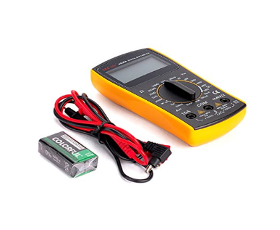

* A **multimeter** or a **multitester** is an electronic measuring tool that is a combination of several tools in one unit. It usually includes an ammeter, voltmeter, and ohmmeter. Digital multimeters are sometimes called **DMM** too.
* Modern multimeters can be used to measure electrical quantities other than current, resistance and voltage. For example, they can be used to measure frequency, capacitance, transistors Hfe, and temperature.
* The multimeter can make many tests, so it is often called "multitester". When measuring resistance it acts as an ohmmeter, showing ohms. For volts it would be a Voltmeter. Sometimes it is called a mixture of things like Volt/ohm meter or VOM. Most meters can measure volts, amps, and resistance.
* A multimeter can be a hand-held device useful for basic fault finding and field service work, or a bench instrument which can measure to a very high degree of accuracy. They can be used to troubleshoot electrical problems in a wide array of industrial and household devices such as electronic equipment, motor controls, domestic appliances, power supplies, and wiring systems.

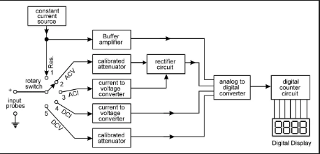

This is a general block diagram of a DMM, as we see, it consists of a variety of options to measure the AC voltages and currents as well as the DC voltages and currents.

Each multimeter comes with two probes/connecters and a set of options.

Turn the dial kind of thing in the direction of the quantity you want to measure and connect the probes across the device you want to measure it.

A basic multimeter facilitates the measurement of the following quantities:

* DC voltage
* DC current
* AC voltage
* Resistance
* Continuity - indicated by a buzzer or tone

Some basic meters don't have an AC current range.

In addition meters may have the following functions:

* Capacitance measurement
* Transistor HFE or DC current gain
* Temperature with an additional probe
* Diode test
* Frequency.

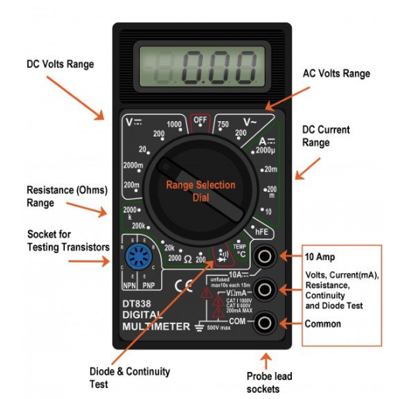

**To measure VOLTAGE:**

1. Connect the positive and negative probes in the last two holes on the multimeter.
2. Now connect the probes to the positive and negative terminals of the circuit respectively.
3. Now set the dial on appropriate range for either AC or DC voltage measurement
4. If the polarities are reversed, the value will have a negative sign.

**To measure CURRENT:**

1. Connect the negative probe to the last probe socket and the positive probe to the first probe socket.
2. Now connect the probes in series to the branch whose current is to be measured.
3. Now set the dial on appropriate range to calculate the DC current.

**To measure RESISTANCE:**

1. Connect the probes in the last two sockets of the Multimeter.
2. Now connect the other ends of the probes to the terminals of the circuit element whose resistance is to be measured.
3. And set the appropriate range of the resistance in the multimeter.

**To check CONTINUITY and DIODES or LEDs:**

1. Connect the probes to the last two sockets and turn the dial to the diode symbol.
2. Now connect the probe across the terminals of the circuit whose continuity is to be tested, if he buzzer sounds, the circuit is complete, else there is air gap.
3. To check the working of an LED, connect the positive probe to the positive terminal of the LED and the negative probe to the negative terminal of the LED.
4. If the LED glows, it is working else it is not.
5. To check if the given transistor is npn or pnp, connect the positive probe to the base of the transistor and the other probe to any other terminal.
6. If the DMM shows a reading then it is a npn type and vice-versa.

***Different types of switches and connectors***

Literal meaning of a switch is “change of state”. In electrical sense, ON and OFF are the two states and switch helps to change the state of an electrical appliance from ON to OFF or vice versa. Strictly speaking, switch doesn’t turn on or off the appliance; it just makes or breaks the contact.

C:\Users\admin\Desktop\Screenshot_8.png

## ***Types of Switches***

There are two broad categories of switches:

1. MECHANICAL SWITCHES
2. ELECTRICAL SWITCHES

*MECHANICAL SWITCHES:*

The types of mechanical switches are classified into four types namely:

* SPST (Single Pole Single through)
* SPDT (single pole double throw)
* DPST (double pole, single throw)
* DPDT (double pole double throw)

1. SPST:

It is a single way switch, also called as a toggle switch.

When the switch is turned ON the circuit is completed and hence current flows and when it is turned OFF, the circuit breaks and current stops.

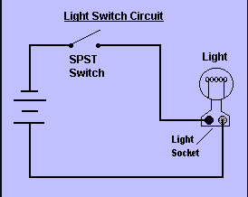

1. SPDT:

This is a three terminal switch with one pole(input teminal) and two throws(output side). Such switches are used in household applications.

The application of SPDT switch is mainly involved in a three-way circuit to turn ON/OFF a light from two locations like from the top & bottom of a stairway.

In the circuit below, when the switch A is closed, then the current flows through the terminals, but only light A will glow and light B will OFF.

When the switch B is closed, then the current flows through the terminals and only light B will glow and light ‘A’ will OFF.

Here two circuits will be controlled through one source or one way.

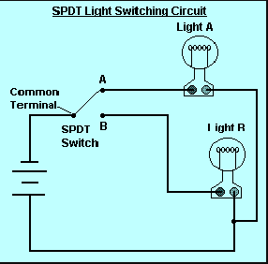

# DPST:

# Double Pole Single Throw (DPST) Switch

A Double Pole Single Throw (DPST) switch is a switch that has 2 inputs and 2 outputs; each input has 1 corresponding output.   
  
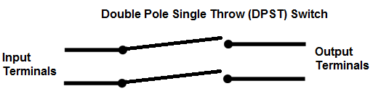

Each of the terminals of a double pole single switch can either be in the on position (closed) or in the off position (open).

A Double Pole Single Switch has a lot of versatility being that it accepts 2 inputs, which makes it then be able to drive 2 different outputs in a circuit. What it drives depends on the circuit design and what the circuit is intended to do. But DPST have enormous applications in circuits.

Below is an example of a circuit which utilizes a double pole single throw switch.   
  
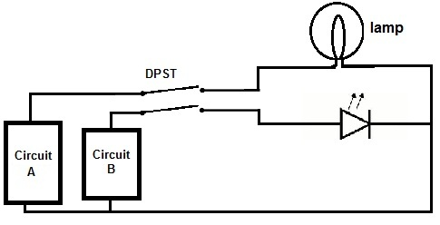

You can see above how a double pole single throw switch can be used to put a circuit in any of 1 of 2 modes. When the switch is connected one way for circuit A and circuit B, the lamp and LED will both be ON. When connected the other way, the lamp and the LED are both OFF.

So a DPST switch allows for control of 2 outputs, turning either both on or both off together.

DPDT:

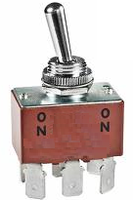

A Double Pole Double Throw (DPDT) switch is a switch that has 2 inputs and 4 outputs; each input has 2 corresponding outputs that it can connect to.   
  
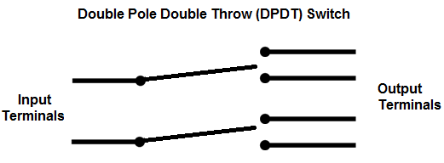

Each of the terminals of a double pole double switch can either be in 1 of 2 positions. This makes the the double pole double throw switch a very versatile switch. With 2 inputs, it can connect to 4 different outputs. It can reroute a circuit into 2 different modes of operation.

A Double Pole Double Throw Switch is actually two single pole double throw (SPDT) switches.

Below is an example of a circuit which utilizes a double pole double throw switch.   
  
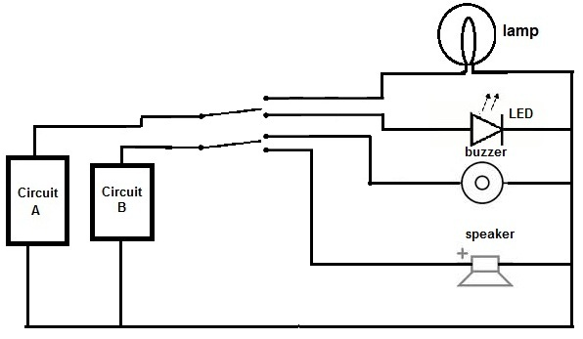

You can see above how a double pole double throw switch can allow a circuit to be in 1 of 2 modes. When the DPDT switch is switched one way (flipped upward in the diagram), the lamp and buzzer are both on, while the LED and speaker are off. When the DPDT switch is switched the other way (flipped downward), the LED and the speaker are both on, while the lamp and buzzer are off.

This shows the dynamic 2-mode capacity that DPDT switches allow, allowing control of 4 different devices (with 2 operational modes).

*ELECTRICAL SWITCHES:*

* 1. Pushbutton Switches – costs under ₹5, used to turn ON and OFF using a simple push.
  2. Limit Switches – costs approx. ₹250, A limit switch is an electromechanical device that consists of an actuator mechanically linked to a set of contacts. When an object comes into contact with the actuator, the device operates the contacts to make or break an electrical connection.
  3. Level Switches - A level switch is a type of level sensor, a device used to detect the level of liquid within a tank. The switch may be used to control a pump, as an indicator, an alarm, or to control other devices.
  4. Pressure Switches - A pressure switch is a form of switch that closes an electrical contact when a certain set fluid pressure has been reached on its input.
  5. Membrane Switches – These switches are generally pressure pods which sense the pressure of touches and get activated.
  6. Rocker Switches - A rocker switch is an on/off switch that rocks (rather than trips) when pressed, which means one side of the switch is raised while the other side is depressed much like a rocking horse rocks back and forth. A rocker switch may have a circle (for "on") on one end and a horizontal dash or line (for "off") on the other to let the user known if the device is on or off.
  7. Rotary Switches - A rotary switch is a switch operated by rotation. These are often chosen when more than 2 positions are needed, such as a three-speed fan or a CB radio with multiple frequencies of reception or "channels".
  8. Emergency Switches - A kill switch, also known as an emergency stop (e-stop) and as an emergency power off (EPO), is a safety mechanism used to shut off machinery in an emergency, when it cannot be shut down in the usual manner.
  9. Ignition Switches - An ignition switch or starter switch is a switch in the control system of an internal combustion engine motor vehicle that activates the main electrical systems for the vehicle.

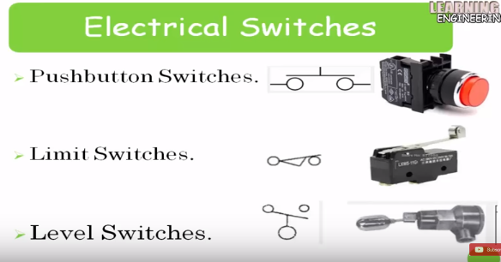

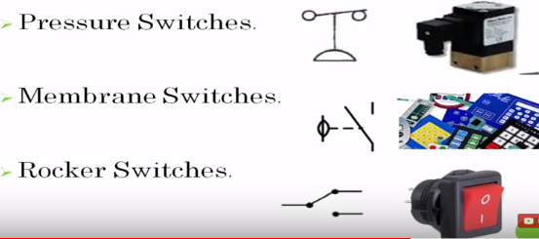

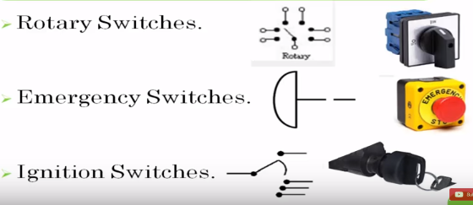

Other several electrical components such as a **BJT, MOSFET, IGBT, SCR, TRIAC, DIAC** can be used for switching purposes.

1. BJT:

In switching circuits, transistor operates as OFF in the cut-off region while it operates as ON in the saturation region.

Saturation region is reached when a sufficient base current is supplied to it.

When the base current is removed and the base voltage reaches a slight negative value, it turns OFF.

In the active region the BJT is used for amplification purposes.

1. MOSFET:

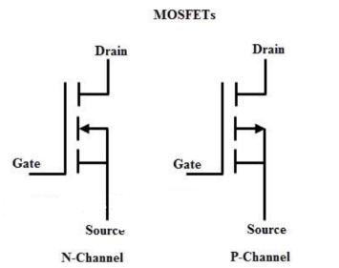

MOSFET is turned ON by applying a positive VGS w.r.t the source. Also this applied VGS. Also this VGS should be greater than the threshold voltage of the MOSFET.

Since it operates and varies with changes in the voltages it is a voltage controlled device.

1. IGBT:

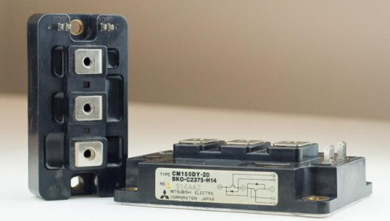

IGBTs are the gate keepers of Current. AS the word ‘Gate’ suggests, when voltage is applied to the gate, it opens or turns ON and creates a path for current to flow between the layers. If no voltage is applied to the gate or if the voltage in not high enough the gate will remain closed and current will not flow resulting in IFF.

1. SCR:

There are three modes of operation for an SCR depending upon the biasing given to it:

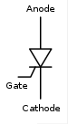

Forward blocking mode (off state)

In this mode of operation, the anode (+) is given a positive voltage while the cathode (−) is given a negative voltage, keeping the gate at zero (0) potential i.e. disconnected.

Forward conduction mode (on state)

SCR can be brought from blocking mode to conduction mode in two ways: Either by increasing the voltage across anode to cathode beyond breakover voltage, or by applying positive pulse at gate. Once SCR starts conducting, no more gate voltage is required to maintain it in the

Reverse blocking mode (off state)

When a negative voltage is fed to the anode and a positive one to cathode, the SCR is in Reverse Blocking Mode making the J1 and J3 reverse biased and J2 forward biased . The device behaves as 2 diodes are connected in series with reverse voltage applied. A small leakage current of a few milliamperes flows. This is the reverse blocking mode. If the reverse voltageis increased, then at a critical breakdown level, called the reverse breakdown voltage (VBR),

1. TRIAC:

TRIAC, from triode for alternating current, is a [generic trademark](https://en.wikipedia.org/wiki/Generic_trademark) for a three terminal [electronic component](https://en.wikipedia.org/wiki/Electronic_component) that conducts [current](https://en.wikipedia.org/wiki/Electric_current) in either direction when triggered. Its formal name is bidirectional triode thyristor or bilateral triode thyristor.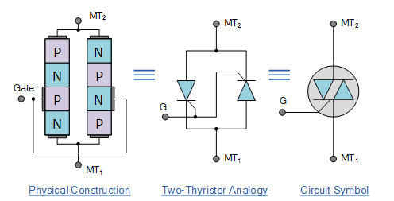

1. DIAC:  
   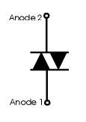

The DIAC is essentially a diode that conducts after a 'break-over' voltage, designated VBO, is exceeded.

When the device exceeds this break-over voltage, it enters the region of negative dynamic resistance. This results in a decrease in the voltage drop across the diode with increasing voltage. Accordingly there is a sharp increase in the level of current that is conducted by the device.

The diode remains in its conduction state until the current through it drops below what is termed the holding current, which is normally designated by the letters IH.

Below the holding current, the DIAC reverts to its high-resistance (non-conducting) state.

Its behaviour is bi-directional and therefore its operation occurs on both halves of an alternating cycle.

***Step up and Step Down converters and substitutes***

The most common step up and step down converters are the transformers.

They work on the principle of Mutual Induction between two coils.

The transformer is static electrical equipment which transforms electrical energy (from primary side windings) to the magnetic energy (in transformer magnetic core) and again to the electrical energy (on these secondary transformer side). The operating frequency and nominal power are approximately equal on primary and secondary transformer side because the transformer is a very efficient equipment, while the voltage and current values are usually different. Essentially, that is the main task of the transformer, converting high voltage (HV) and low current from the primary side to the low voltage (LV) and high current on the secondary side and vice versa.

1. STEP UP TRANSFORMER:

In this type of a transformer, there are less number of windings in the primary coil when compared to the windings of the secondary coil.

As a result of which, the EMF induced in accordance to the secondary coil is more than the primary coil.

Hence, the voltage is increased according to the ratio of the number of turns.

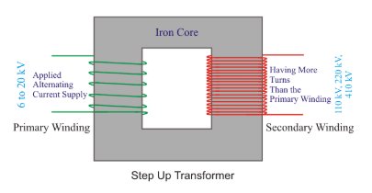

## Applications of Step up Transformer

The small **step up transformer** can be used in electronic and electrical devices where the voltage boosting is required. But nowadays in the modern electronic device, power electronic circuits are more frequently used because of weight and dimension. As we told already, giant power step-up transformer is used as generating step-up transformer for stepping up the generated power to a higher voltage level for efficient transmission purposes.

1. STEP DOWN TRANSFORMER:

In this type of a transformer, there are more number of windings in the primary coil when compared to the windings of the secondary coil. As a result of which, the EMF induced in accordance to the secondary coil is less than the primary coil. Hence, the voltage is decreased according to the ratio of the number of turns.

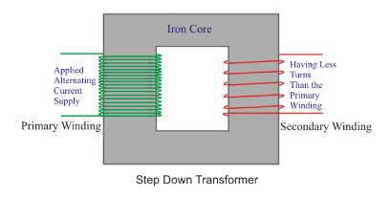

A very naïve alternative to a step down transformer is that we could simply attach a corresponding resistor in series with it.

If we want to reduce the voltage, we connect a resistor in series with the supply and take output across it and if we were to reduce the current of the circuit we can connect resistors in parallel to get the optimum current in a desired branch.

A very everyday application of these step up and step down converters are out mobile chargers they convert a high input ac voltage to a low 5V dc output.

***Express PCB or Eagle PCB- design your previous PBL circuits in PCB***

**I made a very simple Full wave rectifier circuit in the Proteus Simulation software.**

**

